The Central Ohio Chapter
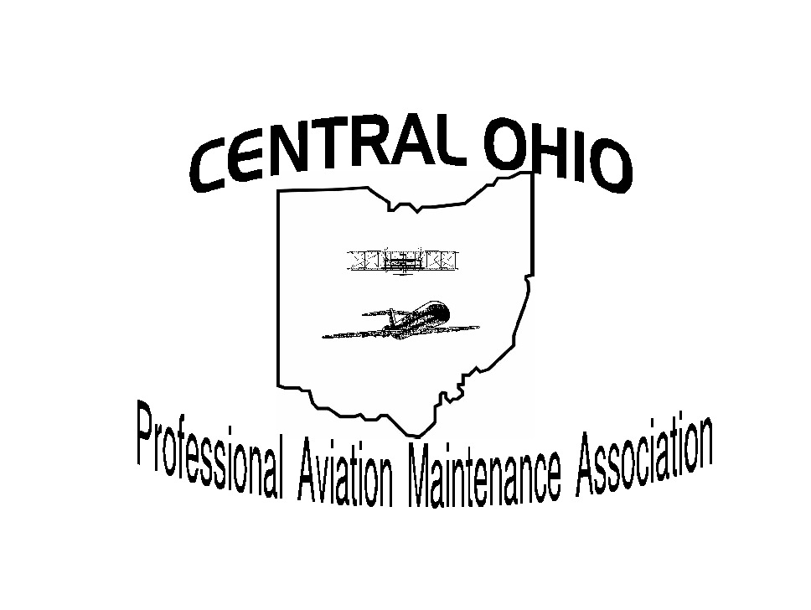

of PAMA & PPA

12th Annual Holiday Dinner
Tuesday
December 9th, 2014

Villa Milano
1630 Schrock Road, Columbus, Ohio 43229

Doors open at 5:30 PM * Dinner at 6:30
Sponsorship form

√ | Level | Amount | Complementary Tickets | Additional Tickets at $15.00 each | Total
 | Gold | $500.00 | 4
 | Silver | $300.00 | 2
 | Bronze | $150.00 | 1
 | Personalized Beverage Coupons - $30.00 for 6 |  |  | Qty
 | I will supply raffle prizes
Tickets will be held at Will Call
Company Name
Contact Name:
Address:
City: |  | ST |  |  | Zip
Phone:
Fax |  | Email

Please provide all requested information. You can also pay with PAYPAL – go to www.copama.org
Credit Card # |  | Type
Name on card |  | EXP
CVC Code **
Signature
**CVC Code found on back side of card.

Billing Address for Credit Card (if different than above)
Street
City, State, Zip Code
Contact Telephone Number
Complete credit card information or mail with check to:
COPAMA
C/O Joe Lippert
7735 Thorncroft Ct

Columbus OH 43235
For info call or contact him at
614/397-1587
Joe.lippert66@gmail.com
Please email your Company Logo

