You are cordially invited to
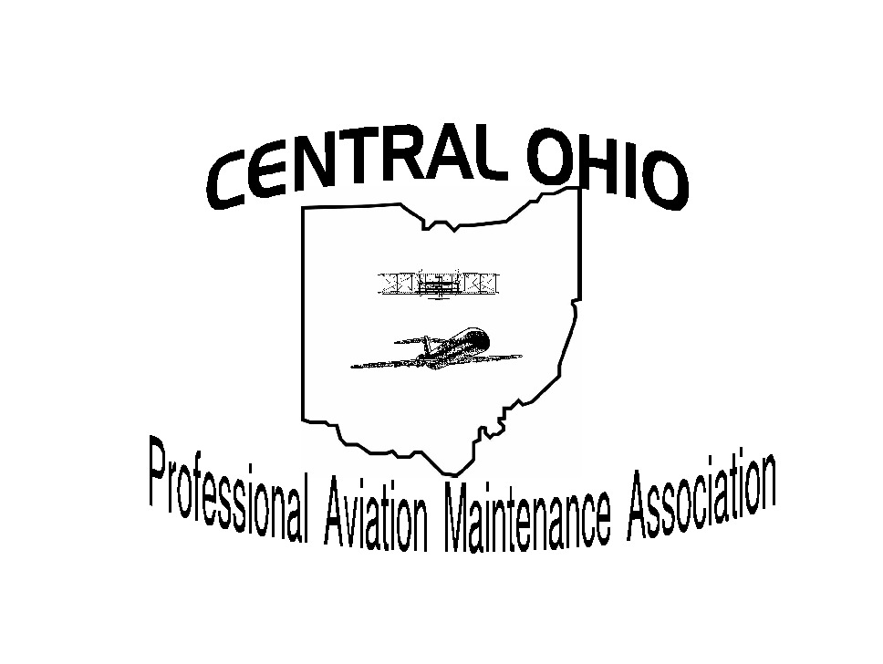


The Central Ohio Chapter
of PAMA & PPA

12th Annual Holiday Dinner
Tuesday, December 9th, 2014

Villa Milano
1630 Schrock Road, Columbus, Ohio 43229

Doors open at 5:30 PM * Dinner at 6:30

$15 per person - Advanced Purchase Required

Tickets can be purchased with Paypal at: www.copama.org/hd2013.htm
Or complete and mail this form. All tickets will be held at Will Call
Name:
Address:
City: |  | ST |  |  | Zip
Email: |  |  |  | Email receipt will be sent
# of Tickets |  | Check or Cash Enclosed
Or bill to my credit card
Credit Card # |  | Type
Name on card |  | EXP
CVC Code **
Signature
**CVC Code found on back side of card. Please provide all requested information.

Billing Address for Credit Card (if different than above)
Street
City, State, Zip Code
Contact Telephone Number

Please send this form and payment no later than December 2 to
COPAMA
C/O Joe Lippert
7735 Thorncroft Ct

Columbus OH 43235
For info call or contact him at
614/397-1587
Joe.lippert66@gmail.com

