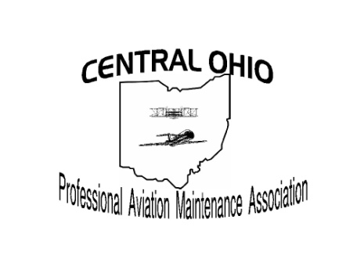
COPAMA Certification Testing Scholarship Application
For students of Columbus State
Aviation Maintenance Technology
Name:
Address:
Phone #:
Email: (suggest personal, not school)
US Citizen?
(If no, please indicate citizenship):
Do you currently hold any FAA Certifications?
If yes, list:
Expected Graduation Date (month & year) | Airframe: | Powerplant:
What percentage of your tuition is paid for with Financial Aid?:

Save your completed form with a file name containing your first initial and last name. Submit along with:
  - Current Resume (two page maximum)
  - One page typed essay explaining why aviation is an important career path for you: to include details of your goals for a career in aviation

Submit completed applications via email to Chris Deem cdeem2@cscc.edu

NOTE: Your submission of an application for a COPAMA Testing Scholarship gives your consent for release of your CSCC Technical GPA for the purpose of scholarship award evaluation.

